Gregory Lyall

Database Management

Professor Reevas

Lab 9

1. Identify and document all function dependencies.
   1. PlayerID |-> FirstName, LastName, Address, Phone #
   2. CoachID|->Position, FirstName, LastName, address phone #,Years Coaching
   3. RosterID |-> PlayerID, CoachID , GroupName, LeagueID
   4. LeagueID |-> LeagueName
   5. GroupName |-> CoachID , TeamName
2. Draw a full annotated E/R diagram that illustrate the Platonic ideal of beautiful and correct relational database design
   1. 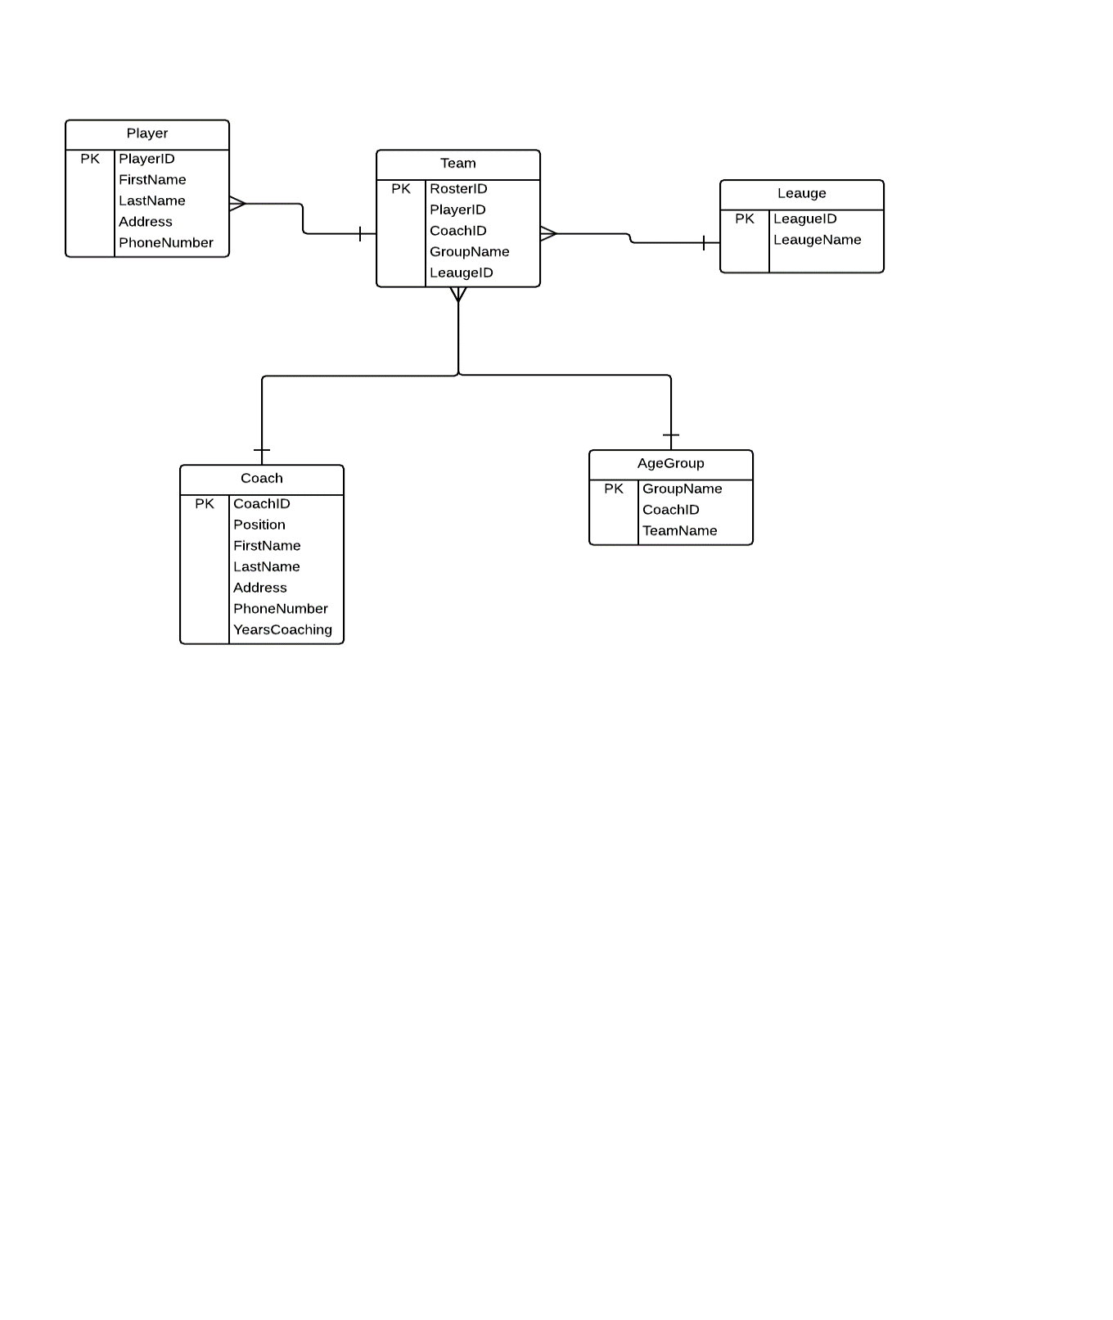
3. Convince me that your database is in 3NF (or even better in Boyce-Cod Normal Form).
   1. I believe this E/R diagram in in 3NF, a Team can only belong to 1 league, A Team can have many players. A player can only belong to 1 team. A Coach can have many teams but only 1 per league. There is no shared data expect the Primary Key.